Hidden Markov Model (HMM) Regime Detection and Model Selection

6. Hidden Markov Model (HMM)

6.1 Objective
The Hidden Markov Model (HMM) was employed to identify latent market regimes in the SPY index between January 2016 and December 2025. Unlike volatility models that only measure the magnitude of market movements, HMM captures underlying market states by jointly modeling return dynamics, volatility characteristics, and market stress indicators.
The primary objective was to estimate the posterior probability of market regimes, which later serves as the $P(t)$component in the Adaptive Composite Market Stress Index (A-CMSI).

6.2 Feature Selection
The Gaussian Hidden Markov Model was trained using standardized market features representing different dimensions of market behavior.
Feature | Description
SPY_Return | Daily logarithmic return
SPY_V | EGARCH conditional volatility
RollingVol21 | 21-day rolling volatility
RollingSkew21 | 21-day rolling skewness
Drawdown | Percentage decline from previous peak
VolOfVol | Volatility of volatility
VIX | CBOE Volatility Index
C_t | Rolling market contagion measure
All variables were standardized using the StandardScaler to eliminate scale differences before model fitting.

6.3 Model Estimation
A multivariate Gaussian Hidden Markov Model was estimated using the Baum-Welch Expectation-Maximization algorithm.
To avoid convergence to local optima, the model was fitted thirty times using different random initializations. The model with the highest log-likelihood was retained.
Model specification:
- Gaussian HMM
- Full covariance matrix
- Maximum iterations = 200
- 30 random initializations

6.4 Model Selection
To determine the optimal number of hidden market regimes, models containing two to six states were estimated.
Each model was evaluated using
- Log-Likelihood
- Akaike Information Criterion (AIC)
- Bayesian Information Criterion (BIC)
- State Occupancy
- State Mean Heatmaps
- Transition Matrix
- Hidden Regime Timeline
- Regime Duration Distribution
- Historical Crisis Validation

Model Selection Results
States | Log-Likelihood | AIC | BIC
2 | -17528.69 | 35239.38 | 35769.84
3 | -15145.50 | 30571.00 | 31387.09
4 | -13754.41 | 27890.83 | 29004.21
5 | -12642.89 | 25773.77 | 27196.11
6 | -11740.13 | 24078.25 | 25821.19
Although the six-state model achieved the largest log-likelihood and the lowest information criteria, additional validation was performed to determine whether the improvement reflected genuine market structure or statistical overfitting.

6.5 State Occupancy
State occupancy was examined to ensure that each hidden state represented a meaningful portion of the sample.
States | Observation
- 2 | Balanced:
- 3 | Balanced:
- 4 | Balanced
- 5 | Balanced
- 6 | All states sufficiently populated
No model contained nearly empty states, indicating that each hidden state was actively utilized.

6.6 State Mean Analysis
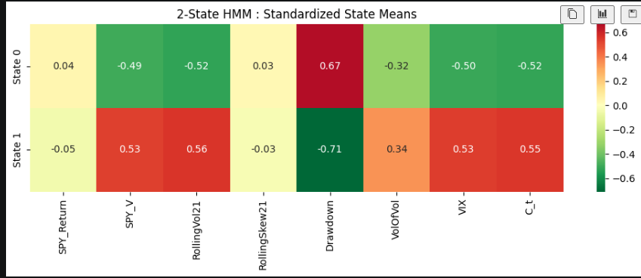
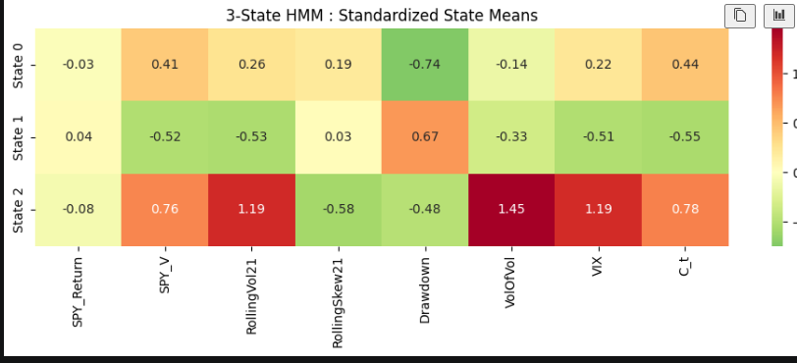
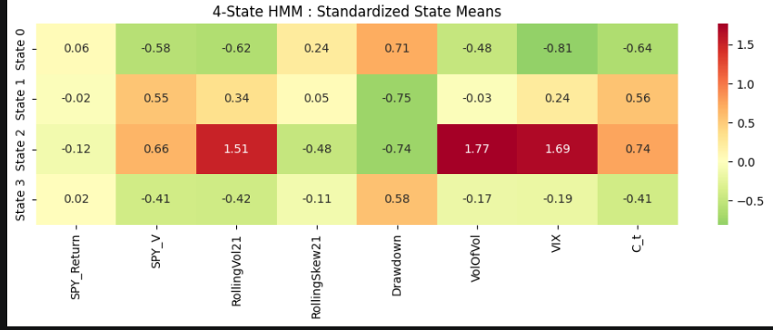
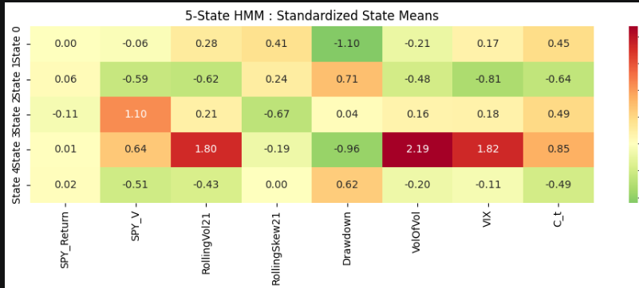
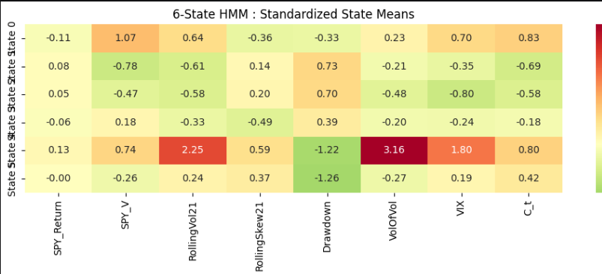
Heatmaps of state-wise feature means were constructed to understand the economic interpretation of each hidden regime.
The analysis revealed progressively richer market structure as additional states were introduced.
The five-state model produced economically interpretable regimes corresponding to
- Stable Bull
- Bull Recovery
- Recovery
- Correction
- Panic
Each regime exhibited distinct volatility, drawdown, VIX and contagion characteristics.

6.7 Transition Matrix Analysis
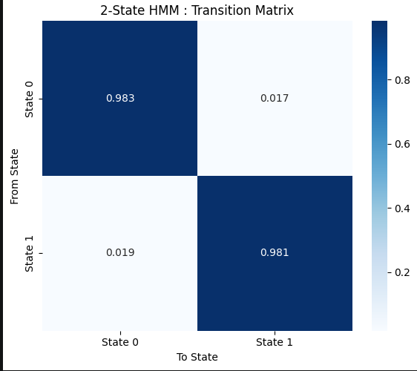
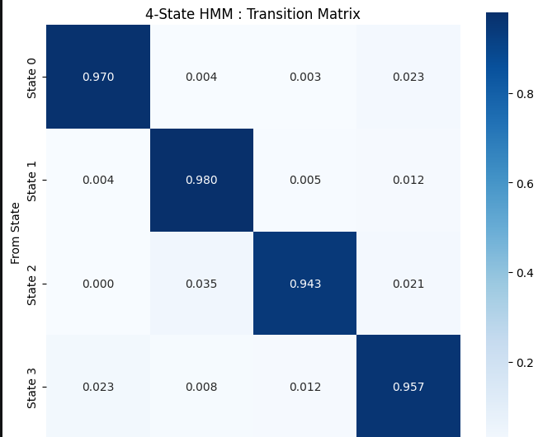
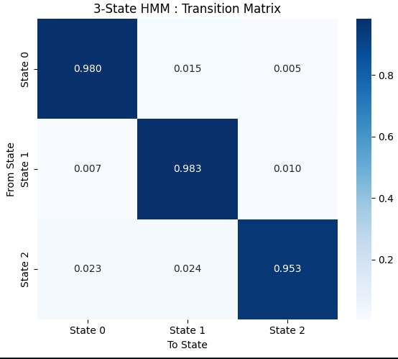
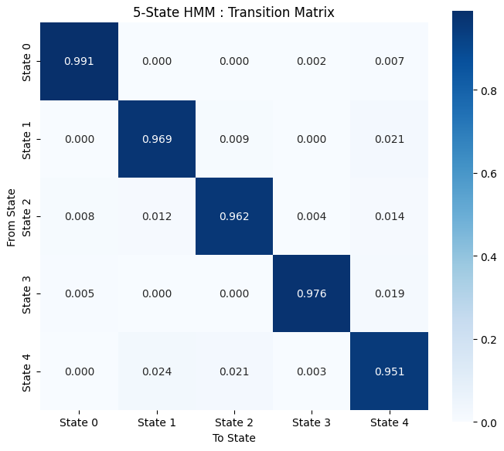
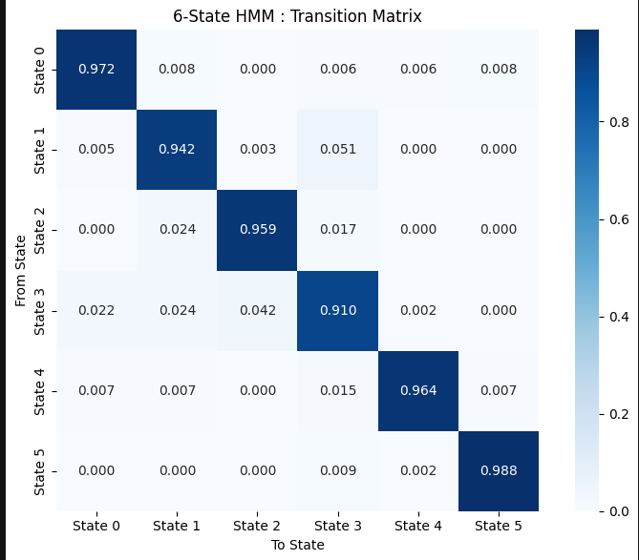
Transition matrices demonstrated that all models possessed highly persistent diagonal probabilities, indicating that market regimes are relatively stable over time.
The Panic regime showed the highest persistence, suggesting that periods of financial stress tend to cluster rather than disappear immediately.

6.8 Hidden Regime Timeline
Hidden regime timelines were visually inspected against historical market events.
Two-state Model
Only separated the market into "calm" and "stress" periods.
Major crises were merged into a single state.
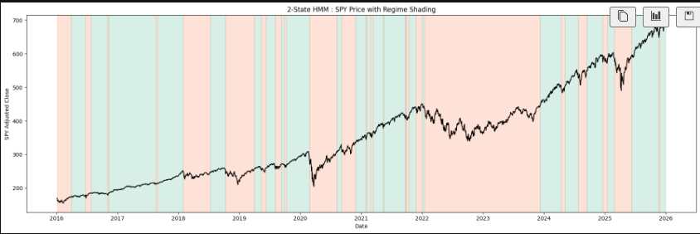

Three-state Model
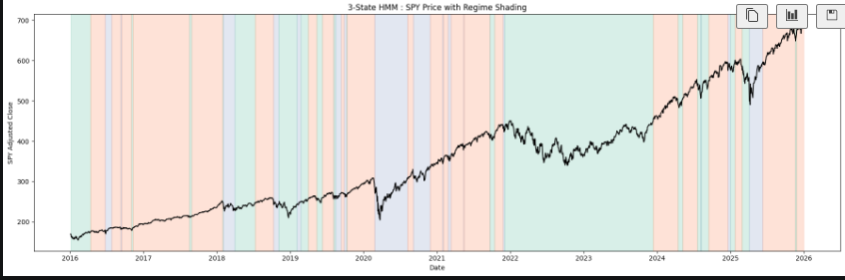
Produced smoother segmentation than the two-state model while introducing an intermediate regime.

Four-state Model
Generated highly coherent regime blocks and clearly isolated several major transitions.
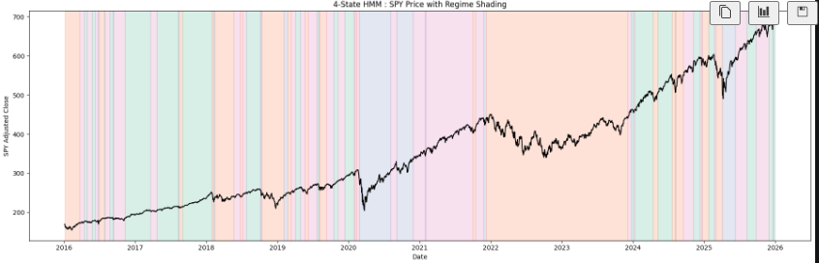

Five-state Model
Introduced additional granularity by distinguishing
- Bull markets
- Recovery periods
- Corrections
- Panic conditions
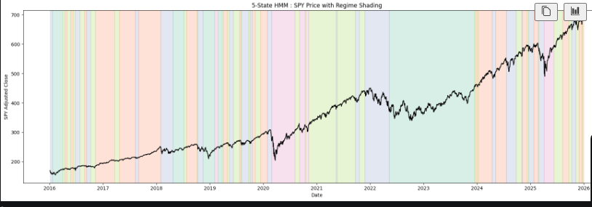
while maintaining relatively smooth transitions.

Six-state Model
Although information criteria improved further, the timeline became increasingly fragmented with numerous short-lived state switches.
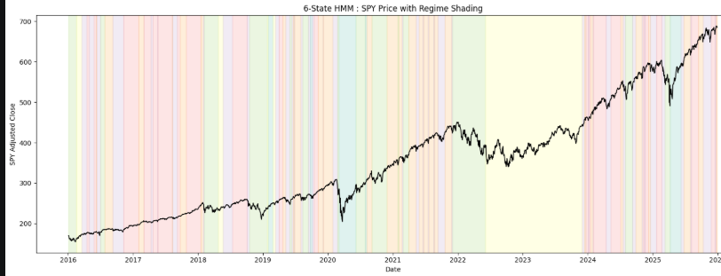
This suggested possible over-segmentation.

6.9 Regime Duration Analysis

Regime duration histograms were computed to evaluate persistence.
Key findings:
- 2-, 3-, 4-, and 5-state models exhibited similar persistence distributions.
- The 6-state model produced substantially more regimes lasting fewer than ten trading days.
- Approximately 40% of six-state regimes were extremely short-lived, indicating statistical overfitting.
The five-state model exhibited the smoothest duration distribution with a realistic balance between short, medium and long-duration regimes.

6.10 Historical Validation
Each model was compared against known financial events including
- February 2018 Volatility Shock
- COVID-19 Crash (2020)
- COVID Recovery
- 2022 Bear Market
- 2023 Recovery
- 2024 Bull Market
Four-State Model
Successfully detected
- Volmageddon
However,
- merged the entire 2022 bear market into one regime,
- failed to distinguish panic from recovery during COVID.
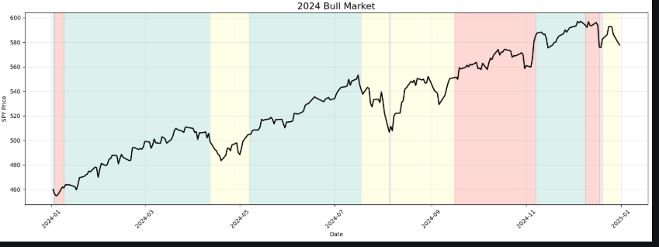
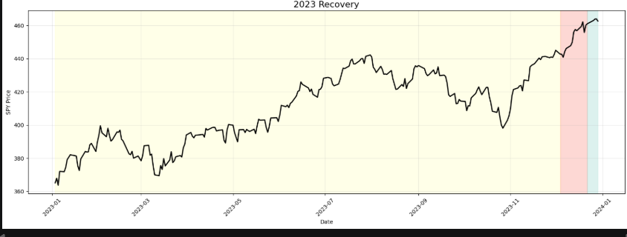
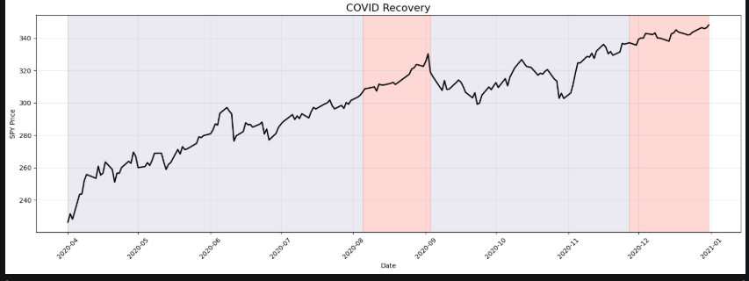
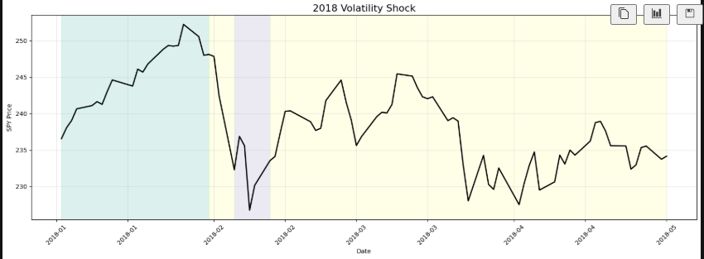
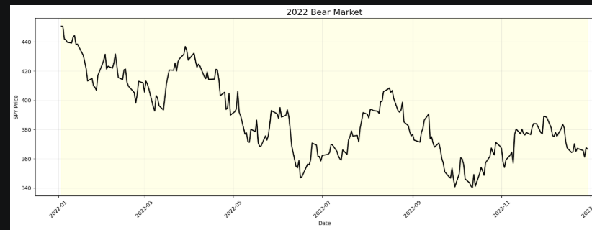
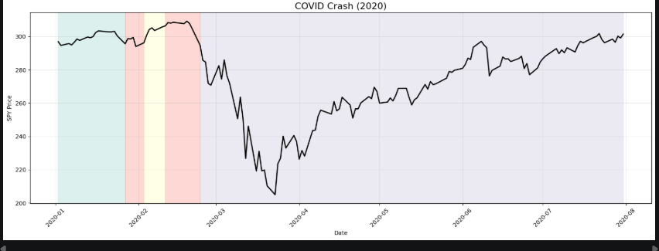

Five-State Model
Improved detection by
- correctly identifying the onset of the 2022 bear market,
- separating recovery pullbacks,
- producing cleaner regime transitions.
Nevertheless,
- the COVID crash and subsequent recovery remained partially merged into a common high-volatility regime, suggesting that the model primarily distinguishes volatility intensity rather than return direction.
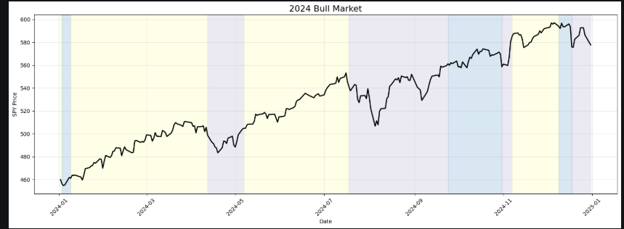
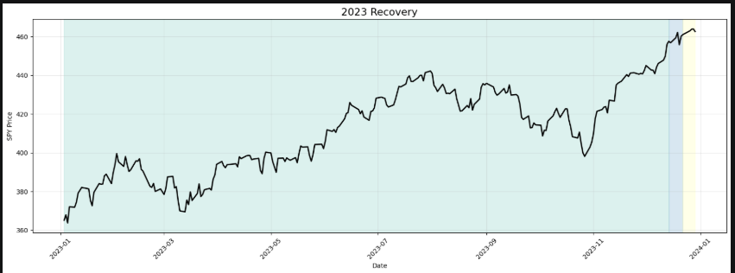
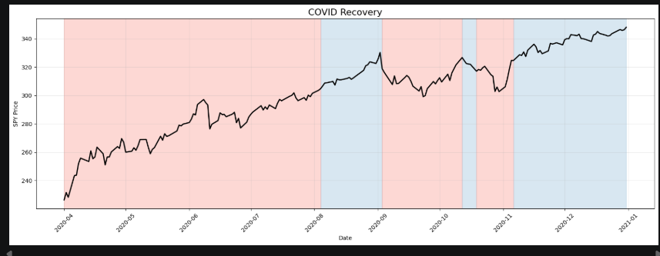
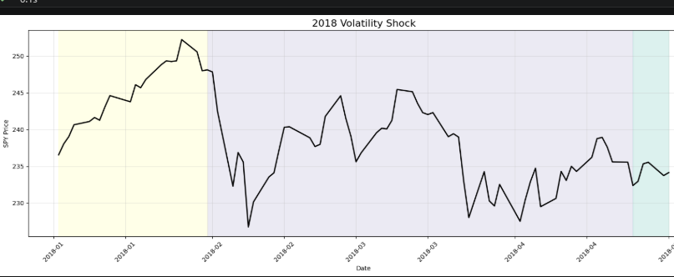
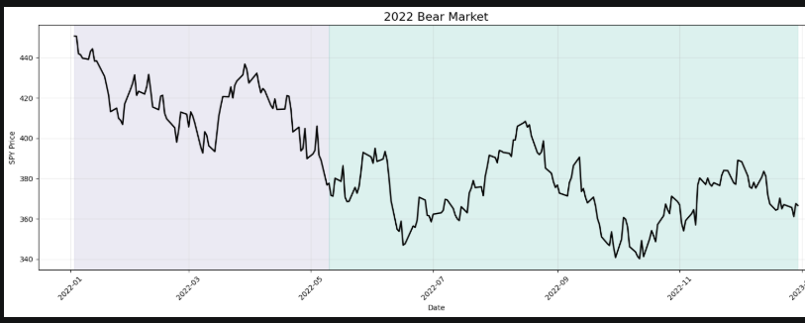
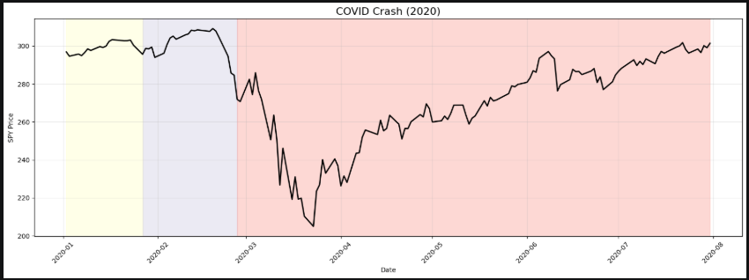

6.11 Final Model Selection
Although the six-state model achieved superior statistical fit according to Log-Likelihood, AIC, and BIC, visual diagnostics and historical validation indicated increasing over-segmentation.
The five-state model provided the best compromise between statistical performance and economic interpretability.
It successfully identified
- Stable Bull Markets
- Bull Recovery
- Recovery
- Market Corrections
- Panic Regimes
while maintaining coherent regime durations and realistic transition dynamics.
Accordingly, the five-state Gaussian Hidden Markov Model was selected as the final regime detection model.

6.12 Posterior Probability Extraction
Following model selection, posterior state probabilities were computed for every trading day using the Forward–Backward algorithm.
For each observation, the model produced
- Hard state assignment
- Regime label
- Posterior probability of each hidden regime
These probabilities constitute the $P(t)$component of the proposed Adaptive Composite Market Stress Index (A-CMSI).
For example,
- $P(\text{Recovery})$
- $P(\text{Stable Bull})$
- $P(\text{Correction})$
- $P(\text{Panic})$
- $P(\text{Bull Recovery})$
Rather than relying solely on hard regime labels, the posterior probabilities preserve uncertainty in regime classification and will subsequently be incorporated into the adaptive weighting mechanism of the proposed index.

